**MULTIPLE LINEAR REGRESSION MODEL**

**Time Series Model**

**Train Data = 80% (June 1977 - May 2011, 34 years)**

**Test Data = 20% (June 2011 - May 2020, 9 years)**

Model 1:

Independent Variables = Q(t-1)

Dependent Variable = Q

Intercept = 22.222744606287854

Slope (m) = 0.5037709

R2_score = 0.45433566366042355

MSE = 9447.324638079808

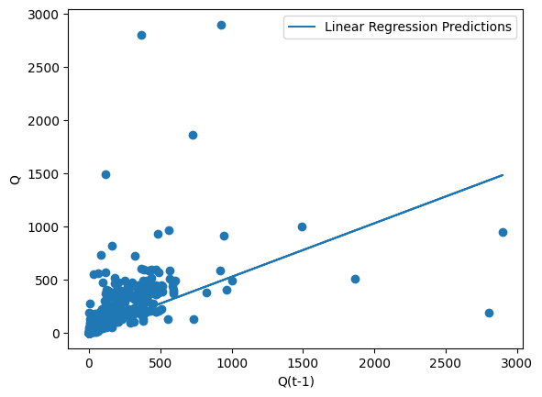

Model 2:

Independent Variables = Q(t-2)

Dependent Variable = Q

Intercept = 28.438461607962342

Slope (m) = 0.36497527

R2_score = 0.3350615727061288

MSE = 11512.3689943154

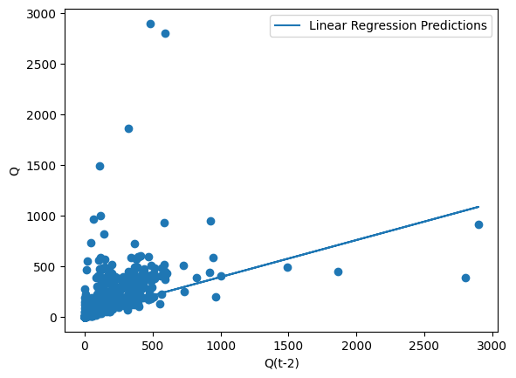 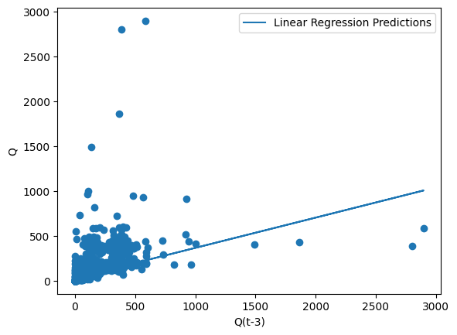

Model 3:

Independent Variables = Q(t-3)

Dependent Variable = Q

Intercept = 29.681859972481142

Slope (m) = 0.33721046

R2_score = 0.28782793968574794

MSE = 12330.145483013326

Model 4:

Independent Variables = Q(t-1), Q(t-2)

Dependent Variable = Q

Intercept = 18.9114323683132

Slope (m1(Q(t-1))) = 0.42870624

Slope (m2(Q(t-2))) = 0.14900555

R2_score = 0.49816025303433853

MSE = 8688.57040883463

Model 5:

Independent Variables = Q(t-1), Q(t-3)

Dependent Variable = Q

Intercept = 17.191624946871766

Slope (m1(Q(t-1))) = 0.4392022

Slope (m2(Q(t-3))) = 0.17691251

R2_score = 0.5043412897740307

MSE = 8581.555423997082

Model 6:

Independent Variables = Q(t-2), Q(t-3)

Dependent Variable = Q

Intercept = 23.871706159484607

Slope (m1(Q(t-2))) = 0.26145078

Slope (m2(Q(t-3))) = 0.20549916

R2_score = 0.39427815856748893

MSE = 10487.126416902665

Model 7:

Independent Variables = Q(t-1), Q(t-2), Q(t-3)

Dependent Variable = Q

Intercept = 16.172389687995164

Slope (m1(Q(t-1))) = 0.40712498

Slope (m2(Q(t-2))) = 0.08691376

Slope (m2(Q(t-3))) = 0.14483528

R2_score = 0.5191371108529153

MSE = 8325.388920690591

**Train Data = 75% (June 1977 - May 2009, 32 years)**

**Test Data = 25% (June 2009 - May 2020, 11 years)**

Model 1:

Independent Variables = Q(t-1)

Dependent Variable = Q

Intercept = 22.10663122965281

Slope (m) = 0.49922392

R2_score = 0.406745928018882

MSE = 12626.717998742692

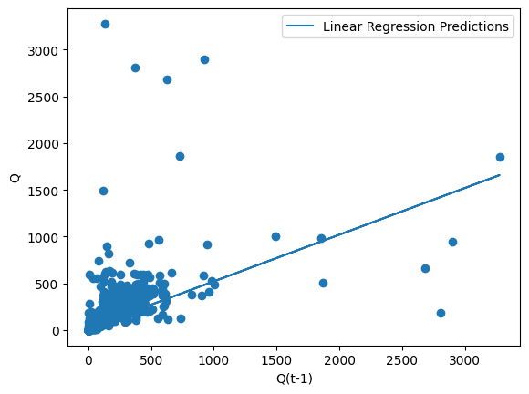

Model 2:

Independent Variables = Q(t-2)

Dependent Variable = Q

Intercept = 28.071840749763762

Slope (m) = 0.3640955

R2_score = 0.2695431879091389

MSE = 15546.917606029412

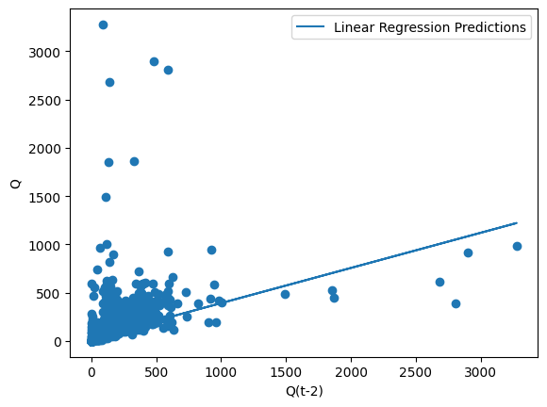

Model 3:

Independent Variables = Q(t-3)

Dependent Variable = Q

Intercept = 29.1369601412296

Slope (m) = 0.33996761

R2_score = 0.22104552976766545

MSE = 16579.133450594745

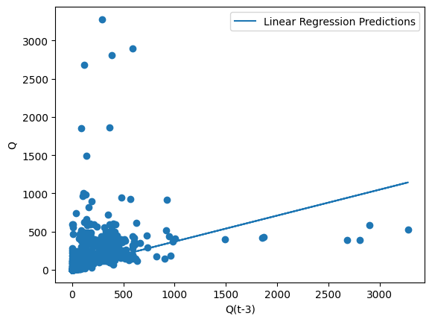

Model 4:

Independent Variables = Q(t-1), Q(t-2)

Dependent Variable = Q

Intercept = 18.724248137693408

Slope (m1(Q(t-1))) = 0.42284112

Slope (m2(Q(t-2))) = 0.1530031

R2_score = 0.43764247255642885

MSE = 11969.121239721011

Model 5:

Independent Variables = Q(t-1), Q(t-3)

Dependent Variable = Q

Intercept = 16.98689763582803

Slope (m1(Q(t-1))) = 0.4328203

Slope (m2(Q(t-3))) = 0.18237969

R2_score = 0.4418756117729895

MSE = 11879.023830092729

Model 6:

Independent Variables = Q(t-2), Q(t-3)

Dependent Variable = Q

Intercept = 23.871706159484607

Slope (m1(Q(t-2))) = 0.25889969

Slope (m2(Q(t-3))) = 0.2107187

R2_score = 0.3118616471254244

MSE = 14646.218772423535

Model 7:

Independent Variables = Q(t-1), Q(t-2), Q(t-3)

Dependent Variable = Q

Intercept = 15.92454200064919

Slope (m1(Q(t-1))) = 0.39996363

Slope (m2(Q(t-2))) = 0.08977862

Slope (m2(Q(t-3))) = 0.14952302

R2_score = 0.45192812481427336

MSE = 11665.06786527802

**Train Data = 60% (June 1977 - May 2003, 26 years)**

**Test Data = 40% (June 2003 - May 2020, 17 years)**

Model 1:

Independent Variables = Q(t-1)

Dependent Variable = Q

Intercept = 19.437785996419265

Slope (m) = 0.55883414

R2_score = 0.21267012335197966

MSE = 21985.573908382015

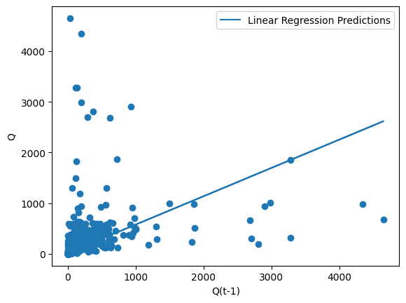

Model 2:

Independent Variables = Q(t-2)

Dependent Variable = Q

Intercept = 25.812440586910903

Slope (m) = 0.4141531

R2_score = 0.13238600053699323

MSE = 24227.445540807817

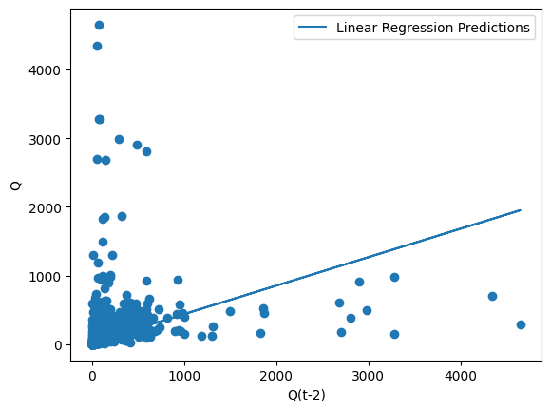

Model 3:

Independent Variables = Q(t-3)

Dependent Variable = Q

Intercept = 27.056040663245682

Slope (m) = 0.38592824

R2_score = 0.1088043610009678

MSE = 24885.944467721893



Model 4:

Independent Variables = Q(t-1), Q(t-2)

Dependent Variable = Q

Intercept = 16.558820871910925

Slope (m1(Q(t-1))) = 0.47606391

Slope (m2(Q(t-2))) = 0.14811231

R2_score = 0.24115663215226402

MSE = 21190.110325459435

Model 5:

Independent Variables = Q(t-1), Q(t-3)

Dependent Variable = Q

Intercept = 14.624588416093971

Slope (m1(Q(t-1))) = 0.4816074

Slope (m2(Q(t-3))) = 0.18646902

R2_score = 0.244433123544344

MSE = 21098.616853920626

Model 6:

Independent Variables = Q(t-2), Q(t-3)

Dependent Variable = Q

Intercept = 21.44597323816262

Slope (m1(Q(t-2))) = 0.28861704

Slope (m2(Q(t-3))) = 0.22463916

R2_score = 0.1672628636401463

MSE = 23253.536288549516

Model 7:

Independent Variables = Q(t-1), Q(t-2), Q(t-3)

Dependent Variable = Q

Intercept = 13.949411370285247

Slope (m1(Q(t-1))) = 0.4527236

Slope (m2(Q(t-2))) = 0.07309166

Slope (m2(Q(t-3))) = 0.15758521

R2_score = 0.2548882570372216

MSE = 20806.665389931633

**Cause Effect Model**